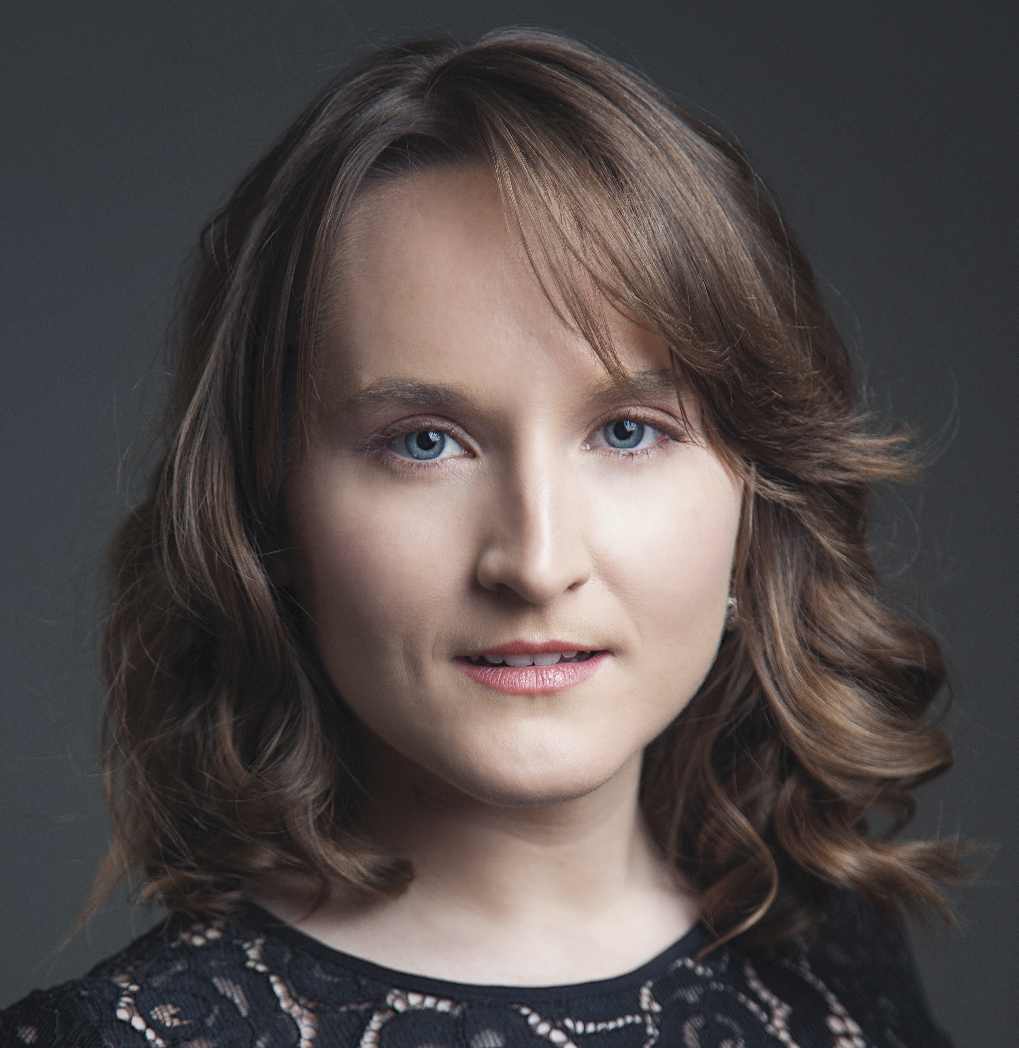
Siena Forest, soprano
www.SienaForest.com / ForestSiena@gmail.com / (508) 395-9009

Upcoming Performances
Frasquita Carmen Lakes Area Music Festival 2017
Opera Roles
Paula Jordan Dinner at Eight (Bolcom) ° Minnesota Opera 2017
Wendy Torrance * The Shining (Moravec) ° Minnesota Opera 2016
First Wood Sprite Rusalka Minnesota Opera 2016
Pamina Die Zauberflöte Minnesota Opera 2015
Echo Ariadne auf Naxos Minnesota Opera 2015
Marie * La fille du régiment Mill City Summer Opera 2015
Frasquita Carmen Minnesota Opera 2015
Jocelyn Jordan * The Manchurian Candidate (Puts) ° Minnesota Opera 2015
Adina * L’elisir d’amore Minnesota Opera 2015
Dew Fairy Hänsel und Gretel Minnesota Opera 2014 Gretel * Hänsel und Gretel Minnesota Opera 2014
Pamina The Magic Flute OK Mozart International Music Festival 2014
Gretel Hansel and Gretel Indiana University Opera Theater 2013
Nannetta Falstaff Indiana University Opera Theater 2013
Mlle. Silberklang Der Schauspieldirektor Carol Vaness’ Opera Workshop 2013
Musetta La bohème Indiana University Opera Theater 2011
Partial Roles
Susanna Le nozze di Figaro Central City Opera 2013
Euridice Orfeo ed Euridice Central City Opera 2013
Noemie Cendrillon Central City Opera 2013
Rose Maurrant Street Scene Central City Opera 2013
Despina Cosí fan tutte Carol Vaness’ Opera Workshop 2010
Oratorio
Soprano Soloist Handel’s Messiah South Dakota Symphony 2015
Soprano Soloist Beethoven’s 9th Symphony OK Mozart International Music Festival 2014
Soprano Soloist Haydn’s Missa Sancti Nicolai Indiana University 2014
Conductors Directors Coaches Teachers
David Agler Michael Cavanagh Robert Ainsley Teresa Kubiak
Michael Christie David Lefkowich Lara Bolton George Smith
Arthur Fagen Eric Simonson Mary Jo Gothmann Carol Vaness
Constantine Kitsopoulos Doug Varone Dale Johnson
Anne Manson Tomer Zvulun Eric McEnaney
Training
Resident Artist Minnesota Opera 2014-2016
Studio Artist Central City Opera 2013
Education
MM, Vocal Performance Indiana University 2014
BM, Vocal Performance Indiana University 2012
Competitions and Awards
Mildred Miller International Voice Competition Semifinalist 2016
Piccola Opera Annual Opera Competition 4th Place 2016
MET National Council Auditions Minnesota District Encouragement Award 2016
Wilfred C. Bain Opera Scholarship Competition at Indiana University 1st Place 2013-2014
Schilling-Tourner Friends of Music Voice Scholarship at Indiana University 2012-2014
Award in Honor of Patsy Rose Musser at Central City Opera 2013
Music Faculty Award at Indiana University 2008-2012
Special Skills: Stage Combat Training with Andrew Moss (summer 2013), Ukulele
* cover ° world premiere ⌃workshop

